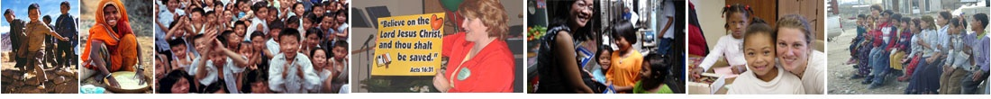

# Child Evangelism Fellowship ®

# Super Seminar Training

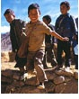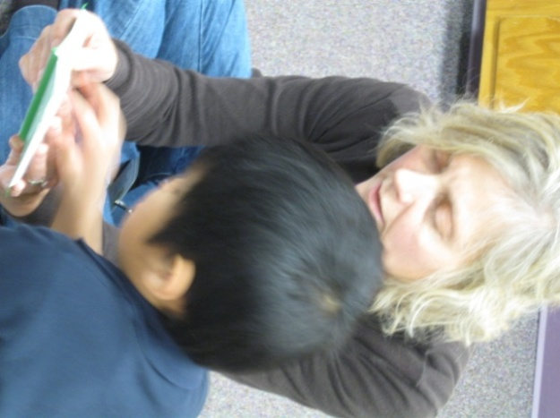

### From a Child’s Perspective

*Understanding Children*

How well do you know the children in your class? Purposefully become child experts of your class in order to meet their needs mentally, physically, spiritually, and socially.

### Discover Your Child’s World

*Age-group Characteristics*

Each stage of childhood is unique! Familiarize yourself with the characteristics that are similar and different at each age group (birth through fourteen).

### I’m Not Too Little!

*Taking the Little Kid Challenge*

Little kids with their wiggles, questions and brief attention spans stretch your ability as the teacher. Gain tips to build a strong foundation and give opportunities for salvation.

### City Kids Ministry Transformation Packet

Many inner city kids have shortened attention spans, limited reading and learning skills and are not getting spiritual leadership at home. Gain some practical tools to share the Gospel that will lead toward lasting life transformation.

### Child Study Seminars

### (4 classes)

*‘Even a child makes himself known by his acts, by whether his conduct is pure and upright.’* (Proverbs 20:11)

* Hands on seminars flexibly designed to meet your group’s specific need and interest.
* Conveniently schedule training into your calendar and *CEF* will come to you.
* Thirty-five seminars covering multiple topics available to choose from once or multiple times.
* Cost: Free will donation

*See other available training ideas on last page*

**For more information**

**or to schedule**

**contact *CEF*:**

**608-782-0614**

**cefofwesternwis@gmail.com**

# *Helping You Evangelize Children*

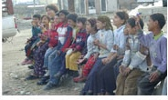

### The Final Authority

*Why Evangelize Children?*

Only God knows the length of life and the heart’s receptivity to the gift of salvation. Hear six biblical reasons why the Gospel should be faithfully shared with children today.

### Inside – Outside

*Ministering to Children Through the Local Church*

*“The church is always but one generation short of extinction.”* (Wiersbe) Come explore ways that the local church can, both inside and outside the church walls, fulfill the Great Commission in the area of children’s ministry.

### Confidential – For Your Heart Only

*Preparing Your Heart to Teach*

*“By failing to prepare, you are preparing to fail.”* (Benjamin Franklin) Teaching doesn’t suddenly happen when you stand up before a class. Look at the significance of teaching God’s Word and basic steps of preparation.

### Drawing in the Net

*The Salvation Invitation*

Children need to not only hear a clear presentation of the message of salvation, but have a chance to respond to that message. Learn why, when and how an invitation can be given.

### Evangelism Seminars

### (5 classes)

*‘Go into all the world and proclaim the gospel to the whole creation.’* (Mark 16:15)

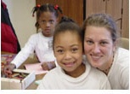

*“The workshop was an encouragement to me with great suggestions.”*

*“What a success the training was. Sunday Fiona decided to use her new knowledge right away.”*

### 1, 2, 3 Jesus Loves Me

*Helping Children Understand the Message of Salvation*

A popular and very practical session giving you tools (Wordless Book or Gospel Flipper-Flapper) to effectively and easily share the message of salvation with a child, providing them the opportunity to accept the Gospel for themselves.

### The Roman’s Road for Children

It once was true that ‘all roads led to Rome.’ Today the important truth is the one way to salvation. Learn to share this message all from the book of Romans on a child’s level.

### Guiding the Child to the Savior

*Counseling the Unsaved Child for Salvation*

You have an awesome responsibility partnering with the Holy Spirit to help a child who is ready to receive Christ as Savior. Through thought-provoking questions learn to clearly counsel a child for salvation.

### Teachers that Change Lives

*A Look at the Teacher*

Teaching is more than imparting facts and knowledge. You have a great opportunity to influence individual lives for eternity. Consider how you can be a ‘favorite’ teacher that God can use for amazing results.

### Life-Changing Bible Lessons:

*Bible Lesson Preparation & Presentation*

Share more than a Bible story with children, preparing and presenting a lesson that encourages life change.

### Evangelistic Lessons

Learn to weave the message of salvation through a Bible lesson.

### Growth Lessons

Learn to weave one Christian growth principal through a Bible lesson that will challenge the saved child.

### Teaching God’s Word Seminars

### (5 classes)

*‘Do your best to present yourself to God as one approved, a worker who has no need to be ashamed, rightly handling the word of truth.’* (2 Timothy 2:15)

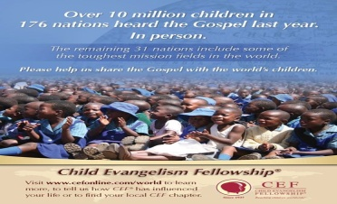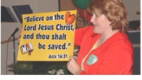

### Class Hour Seminars

### (7 classes)

*‘When you come together, each one has a hymn, a lesson, a revelation… Let all things be done for building up.’* (I Corinthians 14:26)

### Discipleship Seminars

### (8 classes)

*‘Go therefore and make disciples of all nations …teaching them to observe all that I have commanded you.’* (Matthew 28:19-20)

### Around the Corner – Around the World

*Missions – Bringing the World to Your Classroom*

The media has taught today’s children much. But do they know about how the Gospel is impacting these countries and people? Use a brief class segment to teach about missions the world ‘round.

### Kaboom!

*Explosively Fun Classroom Ideas*

Incorporate multi-sensory learning into each part of your class hour to make learning fun and permanent. Leave this seminar with many practical ideas and resources to take back with you.

### Enter His Gates with Thanksgiving

*Learning to Pray*

Only 34% of 8-12 year olds feel that prayer is very important (Barna 2006). Yet this same group communicates frequently with people. Share the privilege of having a conversation with God, who is always available.

### Foundation for Life

*Bible verses – More than Memorizing*

Are kids memorizing scripture as just a string of words for a prize? Learn to teach Bible verses that will stick as the kids understand the concepts and apply them to make a real life difference.

### Review Can Be Exciting!

*Enhancing Learning in a Fun Way*

Do the kids in your class remember what was previously taught? Gather some games and other fun ideas to reinforce good teaching, evaluate past teaching and let the kids have fun.

### Visualize or Fossilize

*Using Visual Aids Effectively*

Visual aids can be used to effectively teach and enhance the learning in your classroom. Come consider how to select and use various visual aids.

### Basic Steps to Maturity

*Teaching New Christians*

What do you first teach after salvation? There are so many important truths to impart! Recognize the essential truths to encourage new growth and build a foundation for future spiritual growth.

### A Living Sacrifice

*Consecration – My Life Set Apart for God*

*‘Present your bodies as a living sacrifice…which is your spiritual worship’* (Romans 12:1). Is this verse written for children to obey? If so, why and how do you explain this command to children?

### I Will Sing a New Song

*Singing – Music with a Message*

### Rarely a day goes by without listening to music and/or singing. How can you use this common and fun tool to teach truths that will stick and deepen the faith of children?

### Managing Your Classroom

*Dynamics of Discipline*

Your role as a teacher can be enjoyable when the kids are well-behaved and properly disciplined. So why aren’t all classrooms exhibiting this behavior? Learn the problems and practical methods to create that ideal classroom.

### Gourmet Food for the Soul

*Growing Through God’s Word*

Train yourself and your class, with practical steps for a daily quiet time, to be students of The Word resulting in a lasting and fruitful habit for all of life.

### One Step at a Time

*Victory Through Christ*

*‘I can do all things through him who strengthens me’* (Philippians 4:13). Recognize the full message of this verse and teach children the steps to victory over sin to daily claim this reality for their lives.

### Developing Knowledgeable Children

*Teaching Doctrine to Children*

The early church taught through ‘I believe…’ statements. Today what do children believe about God? Consider how you can carefully teach foundational scripture truths in a simple way.

### Developing a Biblical Worldview in Children

### *offered in 1 or 2 sessions*

Children are asking deep questions as they think about the world they live in. How do we answer them? The session will look at what is bombarding children and how to instill right values based on solid biblical beliefs. You can guide children to view our world through God’s eyes with Biblical principles and practices.

### Training Children through the Spiritual Disciplines

*"The purpose of the Spiritual Disciplines is …total transformation…"* (Richard Foster) But what are these disciplines and habits leading to transformation? Come learn for your own discipline and also to share with your class.

### Where He Leads Me I Will Follow

*How God Guides Children*

I want to follow God, but what is God’s will for my life? How can I know His will? Teach children about discerning and following the Lord in their lives.

### Conveying Truth thru Images

What comes to mind if you see a red label with white writing on a beverage? Images carry emotions and ideas making them powerful tools to teach abstract ideas. Use images to strengthen your Biblical teaching.

### God’s Good Answers to Kids’ Tough Questions

What does God look like? Kids learn by asking questions, which don’t always have easy answers. Come for some thoughts on how to answer these questions in a truthful, simple and Scriptural way.

### The Wonder of Worship

*‘We were created to worship. It is not an option.’* (Rick Founds) The question is what is being worshipped! Guide the total child into various elements of worship to the glory of God.

### Speak Up – Speak Out

*Training Children to Share their Faith*

When should a believer start witnessing? How old should they be? Harness the excitement and boldness of children, training them with tools to begin a lifetime of witnessing for God.

### Child-Sized Apologetics

*Teaching Kids Why They Believe What They Believe*

*“Christianity, if false, is of no importance, and, if true, of infinite importance …it cannot be moderately important.”* (C.S. Lewis) Know yourself and train your students to defend, not apologize, for Biblical Truth.

### Generation Builders

*Teaching for the Total Child*

For lasting spiritual health and growth, it is not enough to teach only facts. Come see how you must teach the total child (mind, heart and will) that results in true and lasting life transformation.

### Spiritual Formation

*Awesome Ministry to Postmodern Kids*

The nature versus nurture debate continues on and you could agree that both play a role. But for spiritual development, the nurturing example of a caring teacher is greatly used by God to bring children to spiritual maturity.

### cont. Discipleship Seminars



*“Great presentations!”*

### Spiritual Formation Seminars

### (9 classes)

*‘Do not be conformed to this world, but be transformed by the renewal of your mind, that… you may discern… the will of God.’* (Romans 12:2)



*…and many peoples shall come, and say: ‘Come, let us go up to the mountain of the Lord, to the house of the God of Jacob, that he may* ***teach*** *us his ways and that we may* ***walk*** *in his paths.’*

Isaiah 2:3a

Especially designed for those having a passion to take their ministry to a deeper level where true transformation is brought about by the Spirit of God.

# TNT: Teach ‘N Transform

# Conference

## Teaching Children Effectively™

A thirty-hour course designed to equip you to confidently teach the Bible to children. When complete, you will have the skills to study God’s word and write a lesson complete with child applications. Two available levels; level 1 on evangelism (cost $80) and level 2 on discipleship (cost $60). Courses (4-8 weeks) are planned regularly in various locations having a minimum of 4 students per course.

## Christian Youth In Action™

Intense summer training and teaching experience that will transform your life. Two weeks of training prepare you to teach 5-Day Clubs® to children here in Minnesota. Not only learn to share the Gospel clearly, but see God work through prayer and in the children’s lives. Applications available in January and due by March 31 for those 14 years and older. Cost around $500, raised through prayer and letters.

**tce**

TEACHING CHILDREN EFFECTIVELY

# Other Training Opportunities

### Why TNT? Children in Spiritual Crisis

How does God see the child without Christ? How is the world impacting the lives of today’s children? Learn how your children’s ministry can counteract these influences.

### Trigger Transformation

*The Power of the Gospel*

Interactive sessions will develop and enhance your skills in guiding children to a personal relationship with Christ. Learn how to present the message of salvation clearly on a child’s level, using the unique *Gospel Flipper-Flapper™.*

### Transform Your Counseling Skills

Do you know how to wisely and carefully counsel children for salvation? How do you avoid the “easy believism” trap? Learn how to use the right questions to guide children to a genuine decision for Christ.

### Kids Reaching Kids

*The Transforming Power of Peer Evangelism*

Learn how to train kids to effectively share their faith. In his book, *Transforming Children into Spiritual Champions,* George Barna states, “Peer evangelism among children…is one of the most prolific and effective means of evangelism in the nation.”

### Transforming Kids

*Teaching Kids to Establish a Daily Time with God*

Is your children’s ministry producing spiritually mature kids? Learn how to transform children into spiritual champions by helping them establish the habit of spending time with God each day.